CREATING
PEACE AND HAPPINESS FROM WITHIN



Based on the book The Tree of Becoming
By Trevor Morris
Conscioushealing.co.uk

Your true self is a shining spirit. You must be true to that shining spirit above all things. Let nothing draw you aside from your soul's pursuit of truth and light and eternal love.
White Eagle, The Quiet Mind

Our destiny is to discover ourselves and shine our unique light into the world. If we choose to ignore out true self and our true destiny we suffer the effects of fate. Whether we choose to follow our destined path or become the victim of fate is our conscious choice. This choice is not always the easiest choice to make but will bring us inner joy and peace.
Trevor Morris, The Tree of Becoming

The world is full of people suffering from the effects of their own unlived life. They become bitter, critical, or rigid, not because the world is cruel to them, but because they have betrayed their own inner possibilities.
Carl Jung

CREATING
PEACE AND HAPPINESS FROM WITHIN

Based on the book The Tree of Becoming
By Trevor Morris

Trevor Morris is the founder of Conscious Healing and author of the book The Tree of Becoming.

In this short booklet you will find seven key steps to creating peace and happiness based on the principles in his published book illustrated below.

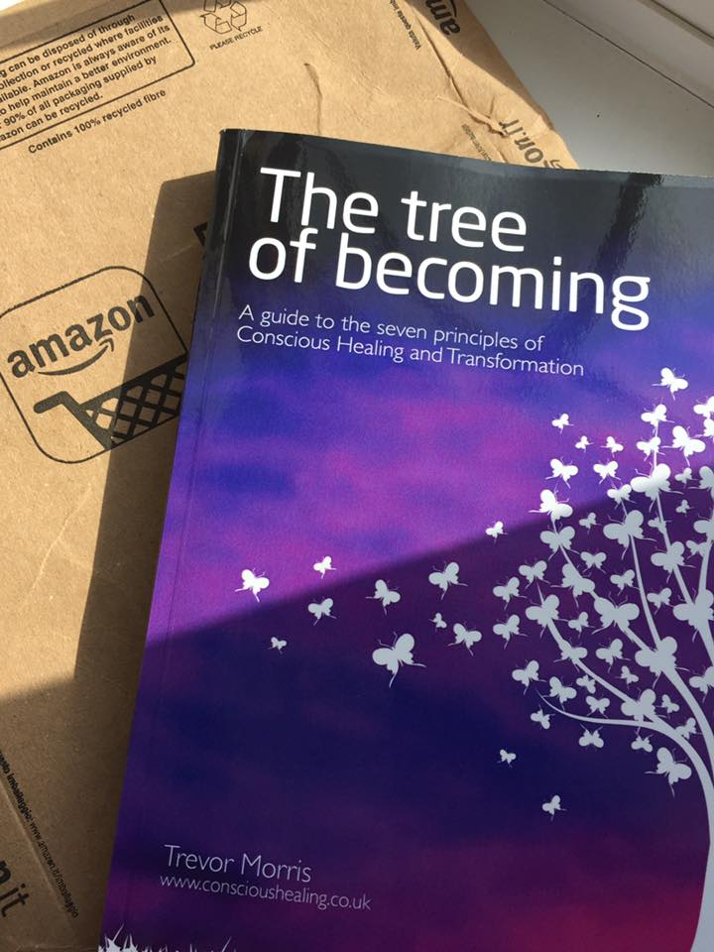
THE SEVEN STEPS TO PEACE AND HAPPINESS

Many people think if they have material things this will bring them happiness. In fact, happiness comes from having love in your life, being your true self and knowing when and how to be still

BE Step 1 Let love in your life
Step 2 Be true to yourself
Step 3 Be still and at peace

DO Step 4 Ask and you will receive
Step 5 Change your beliefs and habits
Step 6 Face your fears and act now

HAVE Step 7 Enjoy and celebrate your life

THE ‘SPIRITUAL’ APPROACH TO HAPPINESS
BE Who do I need to BE in order to be happy
↓
DO What must I DO to become this person
↓
HAVE I attract what I need to HAVE to be happy

This approach is driven by a desire to be your true self and to act naturally. It will lead to a sense of happiness and love within your self, a love for others, and a love for the natural world.

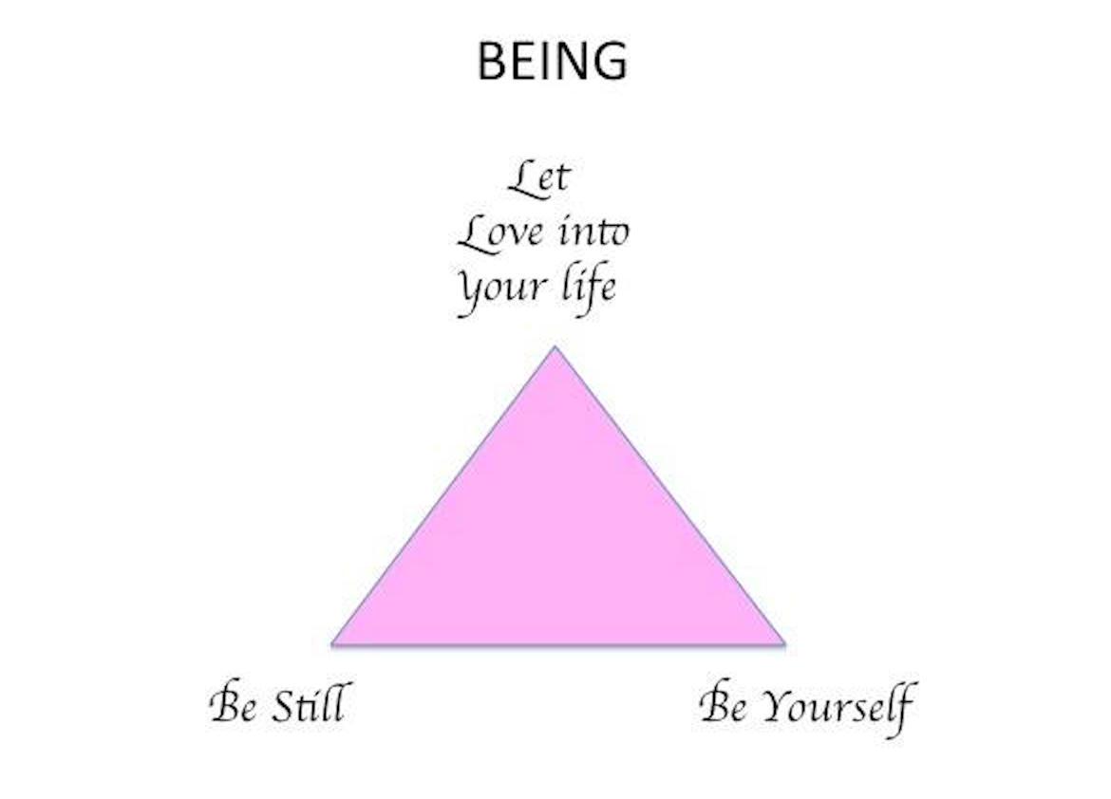
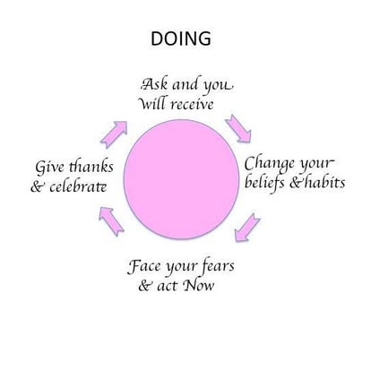

LET LOVE INTO YOUR LIFE

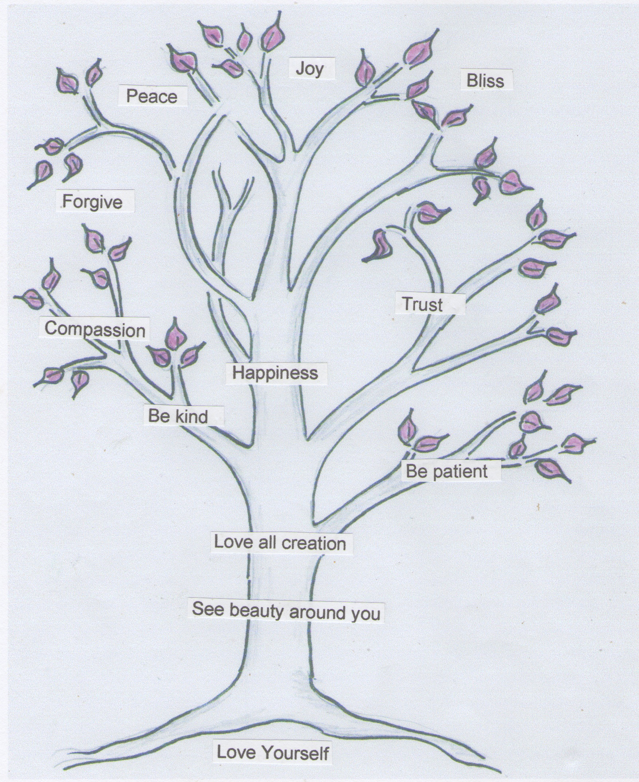

To create more love in your life you need to start behaving differently. This will change the way other people see you, and more importantly, it will change the way you see yourself. Whatever you wish to change, bringing more love into your life will help you attract the things you need.
- Be gentle and love yourself as you are
- Recognise that you have unique talents and don’t feel a need to compete with other people
- See love and beauty around you
- Smile spontaneously and imagine you are sending love to those around you
- Celebrate the good qualities in different people and different cultures
- Be kind and patient towards people
- Give advice only when you want to help, but don’t tell other people what they should do
- Let go of things that happen in your life that you don’t like but are outside of your control
Love the animals, love the plants, love everything. If you love everything, you will perceive the divine mystery in things. Once you perceive it, you will begin to comprehend it better every day. And you will come at last to love the whole world with an all-embracing love.
Fyodor Dostoyevsky

BE TRUE TO YOUR SELF

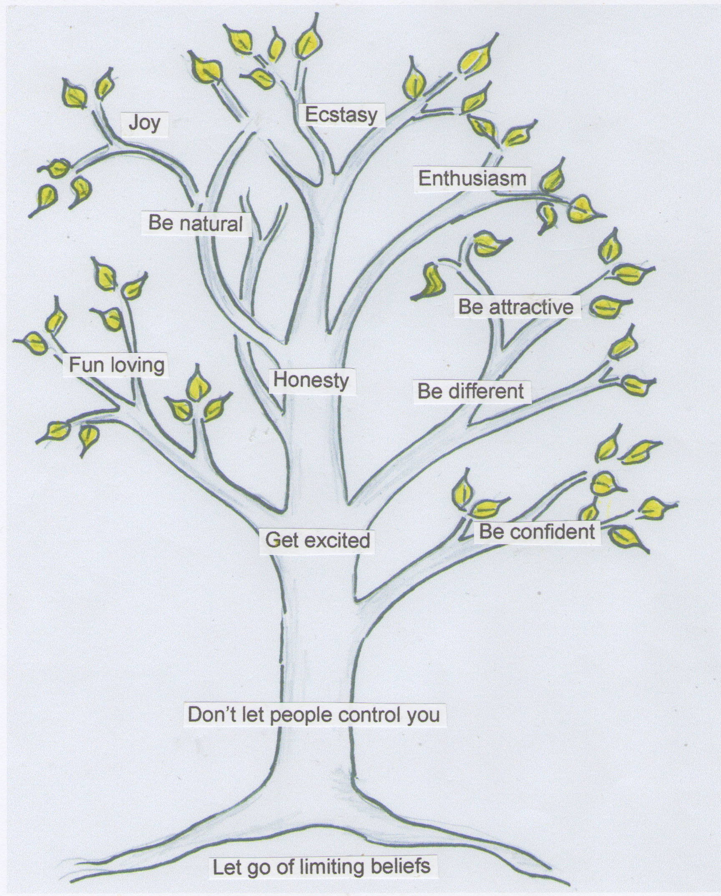

By being true to your self, you will discover the shining spirit that dwells within you. Here are some useful tips to follow taken from the book 'The Tree of Becoming'.

- See life as an exciting game, not a set of outcomes
- Be spontaneous and joyous
- Take risks and join in things even if you are nervous
- Allow yourself to fail and reward yourself for trying
- Speak your own truth
- Read books and watch films that intrigue you or make you feel happy
- Wake up in the morning and see the day as a new beginning
- Celebrate your good points instead of dwelling on problems
- Dress in a way that expresses how you feel and who you are
- Be passionate about things you like
- Remember you are constantly in the act of creating yourself

Kindle the light in yourself, then kindle it in others! Like spreading light by lighting one candle from another all around a room, so we should spread love from heart to heart!
Mahavatar Babaji

BE STILL AND AT PEACE

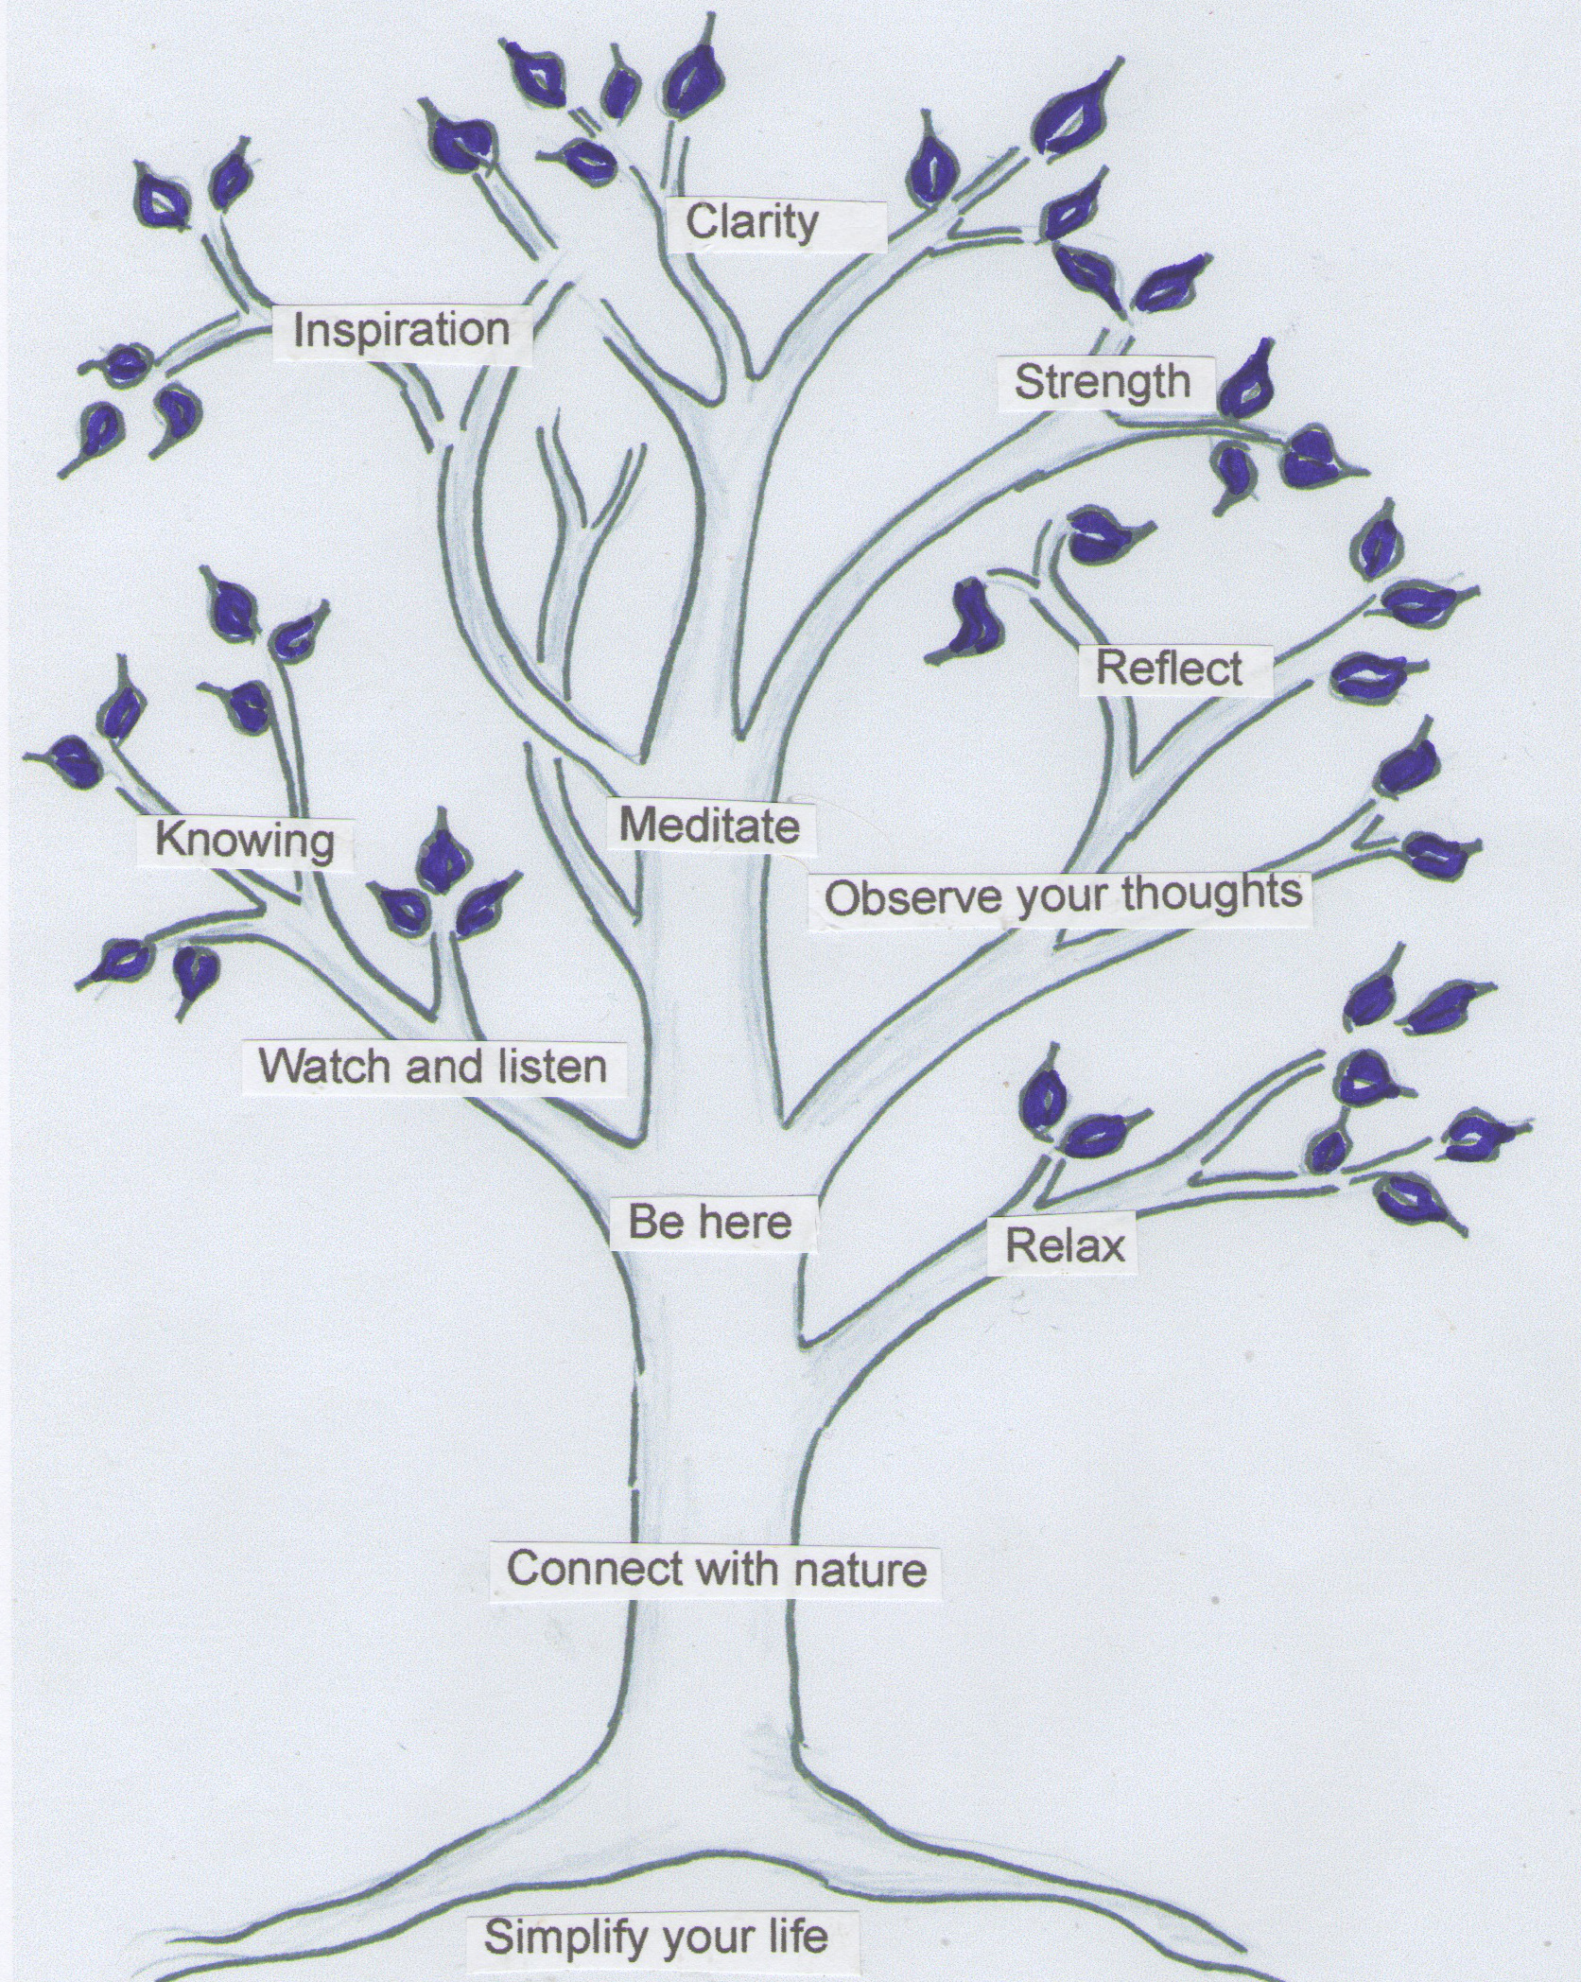
To create happiness in your life you need to learn to be at peace with yourself and the world surrounding you. By being at peace with yourself you will automatically connect with your inner being and your divine connection with life.

By learning to be at peace you will find clarity, strength and inspiration in your life.
- Simplify your life
- Contemplate the beauty of nature that surrounds you
- Walk away from contentious situations
- Learn how to be present and mindful in your daily life
- Make time to chill out when you are very busy
- Observe your thoughts and emotions during the day
- Stop and be still when you are stuck and need inspiration
- Listen to relaxing music
- Meditate when you feel at peace
When the soul contemplates in herself and by herself then she passes into another world; the region of purity and eternity, and immortality, and unchangeableness, which are her kindred, and with them she ever lives, when she is by herself and is not let or hindered; then she ceases from her erring ways, and being in communion with the unchanging, is unchanging.
Plato, Phaedo 79
ASK AND YOU WILL RECEIVE

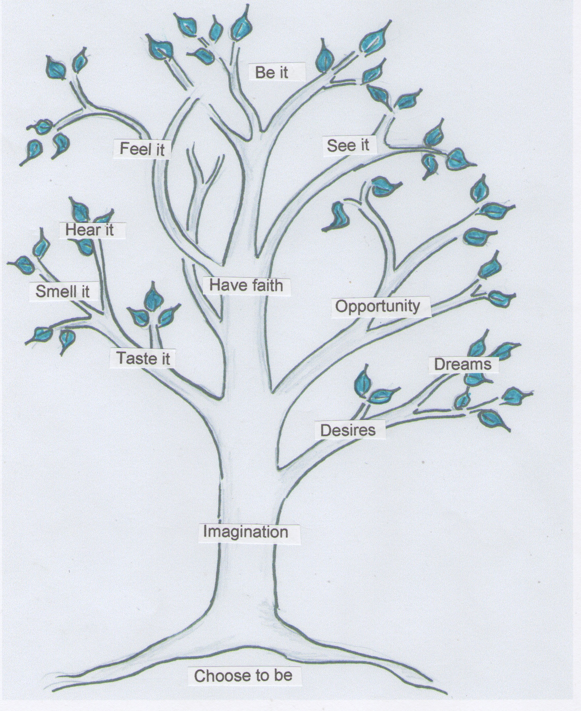

To bring happiness into your life you need to create a clear vision that reflects your new self and decree that it exists right NOW.
- Choose to be happy
- Create a vision statement and imagine doing things in the present moment that make you happy
- Seek to bring happiness and harmony to others as well, as part of your vision
- Before you go to sleep, imagine your new self as if you are in a live movie
- Feel passionate about your new self. Use your senses to feel it, see it, hear it, taste it and smell it
- Believe you deserve to be this new person
- Imagine yourself celebrating your new life, and feel an inner sense of gratitude for all the wonderful things that are now in your life
- Offer up your vision to a higher power and ask (or pray) to be blessed in order to carry out your purpose in life
Thou shall decree a thing, and it shall be established unto thee: and the light shall shine upon thy ways.
The Bible (KJV), Job 22: 28

CHANGE YOUR BELIEFS AND HABITS

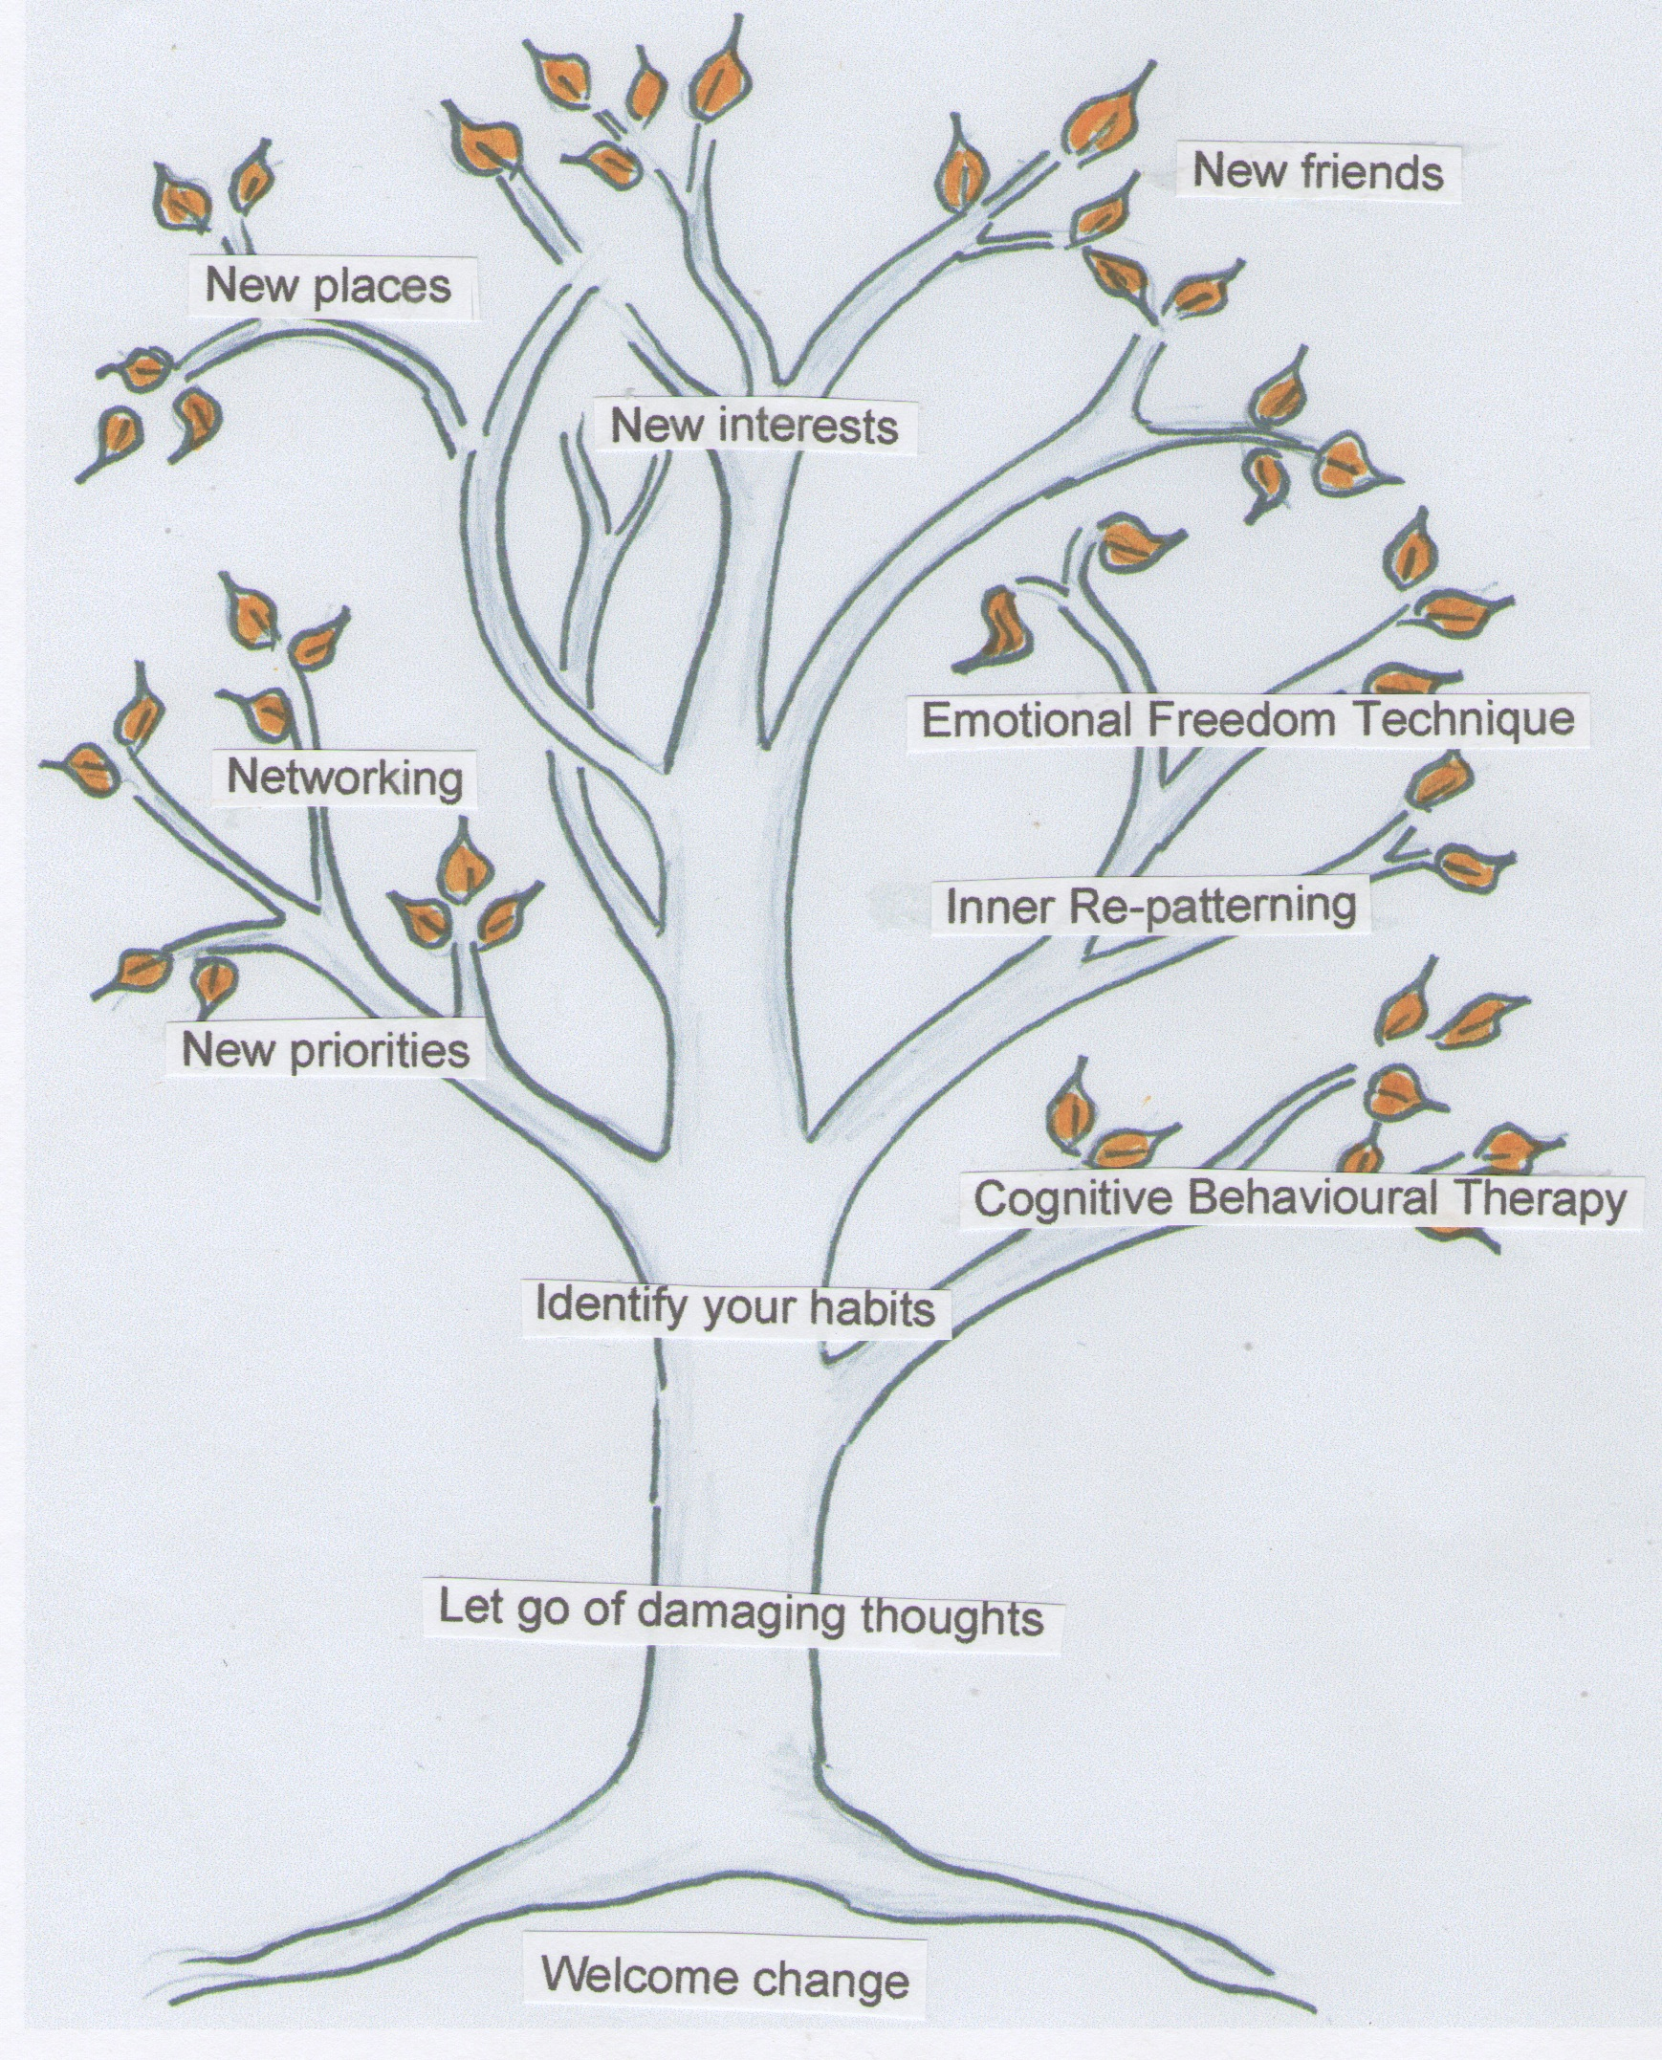

The greatest force preventing you from being happy is the habits you have developed throughout your life up until now. Habits are like the force of inertia; they keep you going in the same direction, in the same groove that you have always been in. They make you feel safe and secure. But at the same time, they are your greatest enemy because they keep you chained in the same familiar prison.
- Gently let go of old relationships that stop you being yourself
- Welcome new relationships
- Do things that make you happy
- Seize new opportunities when they arise
- Don’t dwell on mistakes
- Avoid unhelpful patterns in your life
- Dress in a way that expresses who you are
- Avoid saying negative things about yourself and others
- Go to new places
- Take daily exercise and spend time in nature
- Get rid of unnecessary junk in your home and at work
- Plan a new future if you are unhappy at work
- Accept that change may mean some personal upheaval
We are what we repeatedly do. Excellence, then, is not an act, but a habit.
Aristotle, Greek philosopher (385 - 322 BC)
FACE YOUR FEARS AND ACT NOW

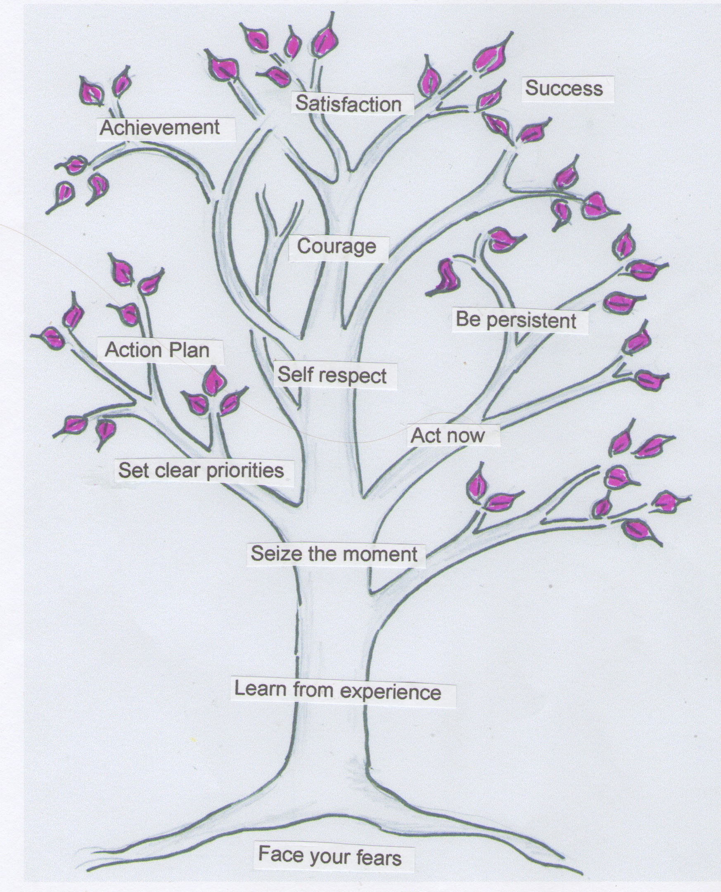
You must start acting right now. It’s no good thinking you will start changing tomorrow. The good news is that you don’t have to change your whole world in a day. What you must do is start to change a little of your world today. Small actions will unlock the creative forces of the universe.
Here are a few useful ideas to help you on your way
- Do something TODAY and every day that is in line with your vision of happiness
- Put a gold star in your diary each day you do something new that makes you happy
- Create an Action Plan
- Make new friends and contacts, and join groups that reflect your goals
- Have the courage to take risks and reward yourself for trying even when you fail
- Seize the moment when opportunities arise
- Act even when you are frightened to do so
- Use your emotions and don’t let them use you
- Watch carefully, your words, thoughts and actions to see they are consistent with the new you
As you begin to change your actions and behaviour you will feel ‘wobbly’ at times. It may even feel that this ‘new’ person is not really you and you want to fall back on the ‘old’ you. This is why it is important to PERSEVERE UNTIL YOU MAKE IT. After a while this new identity or persona will really BE you.
BE JOYFUL AND CELEBRATE
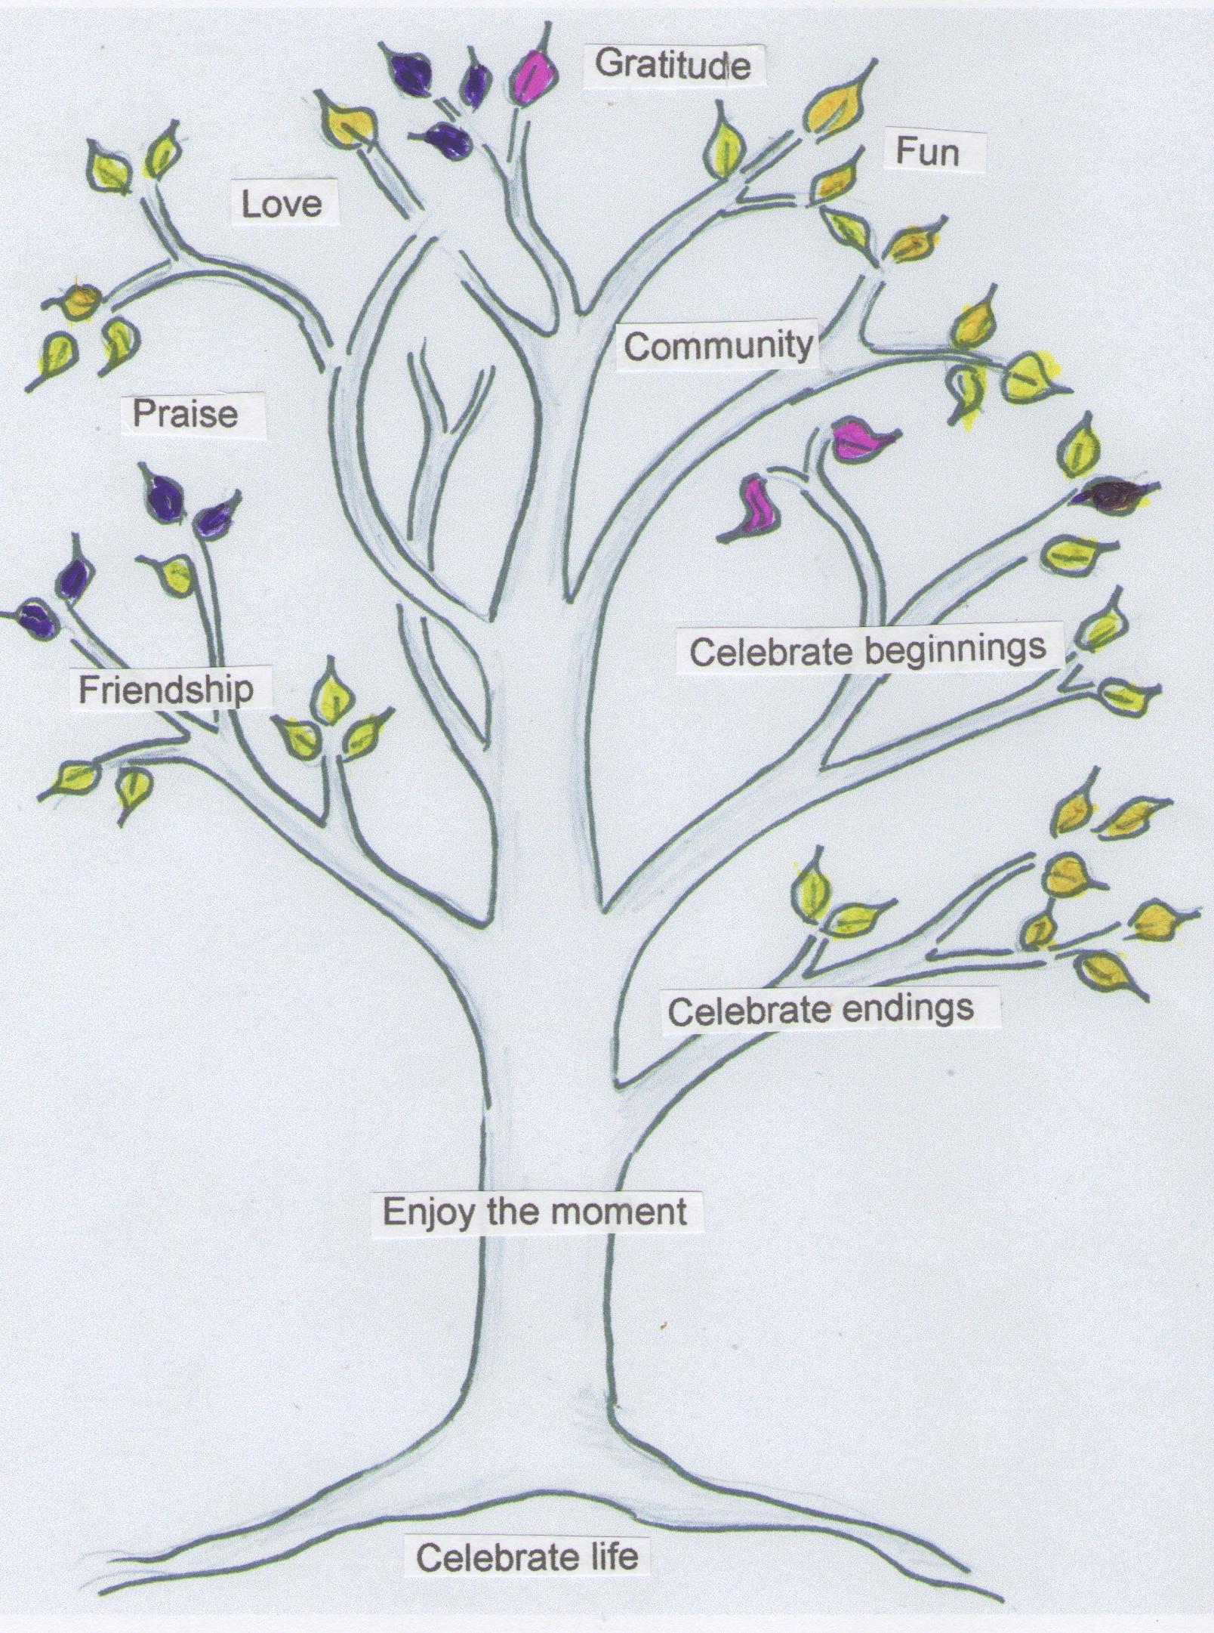
Stop for a moment. Imagine little children playing together; the way they jump up and down, laugh and scream and are completely immersed in the moment. Is this a joy and celebration of life that you have forgotten? It is your natural state of being, the spiritual realm from which you came and the spiritual realm to which you can return if you are simply your true self.
Celebrating your happiness and the happiness of others opens a magical doorway that allows more good things to happen. The more you celebrate the good things in life, the more good things will happen to you.
Here are a few ways you can celebrate your life, and the life of others.
- Be happy and smile when you see, hear and feel beautiful things during the day
- Spend time in nature and experience a sense of bliss
- Meet family and friends to celebrate birthdays and festivals
- Play games with your friends and family
- Do small things that make you and others happy
- Compliment people you like and admire
- Celebrate your own and other people’s success
- Celebrate new beginnings
- Give thanks and honour the Light within yourself and all creation
The Tree of Becoming by Trevor Morris.
Available from the author and from Amazon
This book contains a treasure trove of guidance, inspiration and practical exercises. It successfully draws upon a range of spiritual teachings and indicates how these are relevant and applicable today. Within these pages you will be delighted by the masterful arrangement of such topics as cultivating gratitude, giving and receiving love and creating a sense of well-being in your life.
Dr Melanie Chan, author of: Life Coaching - Life Changing, O-Books.
Contemporary Representations of Virtual Reality, New York, Continuum.

